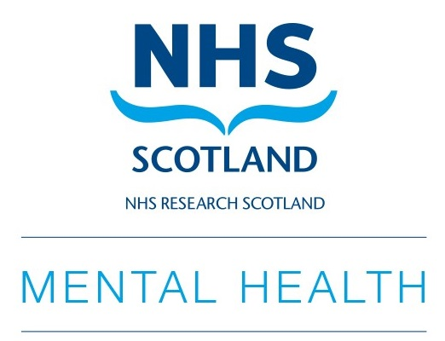

NRS Mental Health Network

Annual Scientific Meeting

‘Lost in Translation?
Bringing research evidence to practice and policy’

29th October 2019

University of Strathclyde Technology & Innovation Centre, Glasgow

Poster Submission Guidelines

Poster abstract submission due by 5pm 04/10/2019

Please keep your abstract at approx. 300wds in total

All posters around the theme of mental health research are welcome

Posters outlining work that is in progress but has not been completed are welcome

Poster abstracts will be reviewed and presenters will be notified by email if they are successful

There are poster prizes available in two categories: student and post doc/established

Posters must be displayed in portrait form (A0)

Please complete and return the form below to Lisa Martin at lisa.y.martin@ed.ac.uk

Presenter name
Position
Organisation
Email address
Poster Title
Authors and Affiliations
Introduction and Aims
Methods
Results
Discussion

